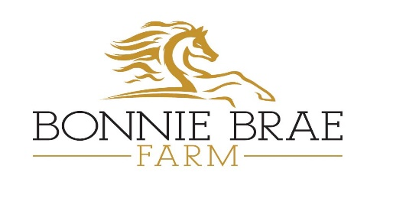
Certificate of Vaccinations
One form per horse to be completed by a veterinarian and submitted to Bonnie Brae Farm office prior to entry to property.
Name of Horse: _________________________________________
Name of Owner: _________________________________________
Date and Name of Required Vaccinations
Date for EHV-1/4 (Rhinopneumonitis): | Name of vaccine:
Date for Streptococcus: | Name of vaccine:
Date for EIV (Influenza): | Name of vaccine:
Date for 5 way vaccine: | Name of vaccine:
Date for combination Flu/Rhino: | Name of vaccine:
Date for West Nile | Name of vaccine:
**Recommended – Rabies: | Name of vaccine:

Name & phone number of Veterinarian: ____________________________________________
The horse named above has not shown any symptoms of, or been treated for, EHV-1/4, EIV or Strangles within the past 28 days.
The horse named above has not been exposed to any horses that have shown any symptoms of, or been treated for, EHV-1/4, EIV or Strangles within the past 28 days.

I (Vet), ______________________________ (print name) agree with the above statements.
________________________________ (Signature) Date: ____________________________

